FY 2018-2019

Santa Cruz Public Libraries Budget

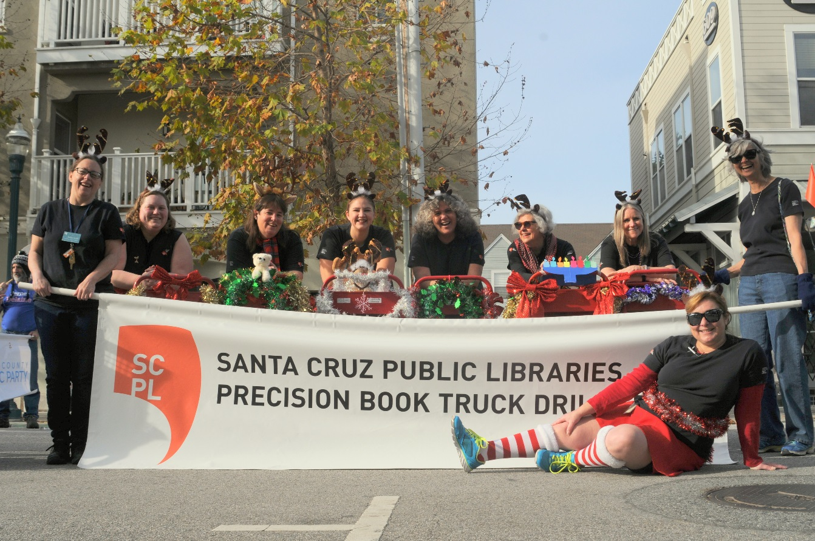

Library Directors Budget Message 2-3

Library Purpose/Mission/Vision/ 4

Organizational Chart 5

Library System Goals 6

Library System Benchmarks 7

Governance, Funding and Budget 8-9

Budget Assumptions 10-12

Adopted Budget Overview 13-15

Projected Library Revenues 16

Projected Library Expenditures: Major Changes 17-20

Projected Library Fund Balance 21

Proposed Changes 22-26

Position Listing by Classification 27

Appendix A: Expenditures by Administration & Branch

Administration 28-29

Aptos Branch Library 30

Boulder Creek Branch Library 31

Branciforte Branch Library 32

Capitola Branch Library 33

Downtown Branch Library 34

Felton Branch Library 35

Garfield Park Branch Library 36

La Selva Beach Branch Library 37

Live Oak Branch Library 38

Scotts Valley Branch Library 39

Outreach 40

Appendix B: Trust Fund Narratives 41-45

Appendix D: Vehicle Replacement Schedule 46

Appendix D: Letter of Support from School Superintendents for the Removal of Children’s Late Fees 47

June 7, 2018

Santa Cruz Public Libraries

Joint Powers Board

117 Union Street

Santa Cruz, CA 95060

Dear Board Member:

Thank you for giving the Santa Cruz Public Libraries the opportunity to deliver the fiscal year 2018-2019 budget request. Measure S funds and strategic investments in operations will provide the opportunity for SCPL to transform its building and services to meet the changing needs of the residents of Santa Cruz County and inspire the next generation to grow and prosper in this community.

Library staff have been working diligently to improve programs and services over the last eighteen months in anticipation of the upcoming physical changes. Over that period of time, they have:

* Piloted the addition of 72 hours per week of additional open hours across ten library branches providing day/evening/weekend hours in all regions and establishing minimum expectations of 36 open hours per week at all sites. The number of visitors in the building has increased and program room use is up by 13%.
* Worked closely with JPA jurisdictions and community members to: develop design and construction documents for new libraries in Felton and Capitola; create remodeling programs for La Selva Beach, Boulder Creek, and Live Oak; and lead a process to define the scope of services and siting recommendation for the Downtown Branch Library.
* Transitioned the libraries to CENIC 10 GB internet connection with 1 GB interconnects (fiber), expanded traditional computing and developed laptop check out program, upgraded Wi-Fi networks and added wireless printing. Hours of public computer use is up by 34% overall and up by 50% at the Downtown Branch.
* Developed an employee innovation program and funded seventeen local projects focusing on transforming programs and services and empowering staff.
* Worked closely with the City of Santa Cruz and local nonprofits to create seamless services for individuals experiencing homelessness.
* Created consistent behavioral expectations by implementing a new, employee designed code of conduct and suspension process while working with the City on security issues and with staff on training. Reported incidents are down by 35% over the same period last year.

The revenue outlook for the Santa Cruz Public Libraries remains mixed. The libraries rely heavily on sales tax revenue, an increasingly volatile revenue in environments with a declining sales tax base and potential for an economic slowdown (see page 11). The libraries also utilize property tax revenue that is not projected to grow based upon a prior five-year agreement between the JPA Board Members.

The expenditure outlook is also of concern as staffing, pension and health care costs are expected to grow significantly in the near future (see pages 11-12). Projected expenditures are likely to begin to exceed projected revenue in the fiscal year 2021.

A recent history of conservative budget assumptions has resulted in a large fund balance. The JPA Board recently increased the budget reserve from 15% to 20% of revenue. They have assumed a $400k annual capital equipment reserve account. Projections still estimate an unreserved fund balance for this system of $2.1-2.6 million. SCPL would like to maintain the unreserved balance in the short run to assist in the development of a long term strategy for building maintenance.

The library is making only small or one-time requests for additional spending that should not exceed current revenue projections. Specifically, SCPL has requested:

1. Elimination of children’s fines $ 25,300
2. Innovation Grant funding $ 50,000
3. Restroom Cleaning $ 45,000
4. One-time building maintenance $100,000
5. One-time temporary staffing $100,000
6. One-time books & materials $150,000

The next five years are likely to be a period of chaos as construction of buildings require a constant shifting of staffing and public service hours. The JPA has agreed to annually review public service hours by branch and agreed to a scheme for FY2019 last month that would redistribute staff and hours from the Capitola branch during its closure to Live Oak and Aptos.

The full 2018-2019 Work Plan goals are being completed and will be provided in the August JPA Board packet. Broadly, the work plan will focus on reframing the Library’s service model and improving the user experience, investing in staff training, making progress on the system’s building and remodeling plans and developing a long term strategy for building maintenance.

Thank you for giving me the opportunity to serve the Santa Cruz Public Libraries. The system has made huge strides and is poised for even greater success.

Thank you,

Susan M. Nemitz

Director, Santa Cruz Public Libraries

**Purpose – Vision – Mission**

**__________________________________________**

**Our Purpose**

Connect, Inspire, Inform

**Our Vision**

Transform lives & strengthen communities

**Mission Statement**

The Santa Cruz Public Libraries enhance Santa Cruz County’s quality of life by providing vibrant physical and virtual public spaces where people connect, discover, and engage the mind. All ages have the opportunity to nurture their love or reading, find diverse and relevant resources for entertainment and enrichment, and strengthen community networks.

Library Joint Powers

Authority Board

Director

1.0 FTE

Assistant Director

1.0 FTE

Collection

Management Services

14.75 FTE

Friends of the Santa Cruz Public Libraries

Library Information Technology

7.0 FTE

Administration/

Maintenance/Courier

7.25 FTE

Organizational

Effectiveness

4.0 FTE



The Valleys

(Scotts Valley,

Boulder Creek &

Felton)

11.125 FTE

North County

(Downtown, Garfield Park & Branciforte)

21.25 FTE

Mid County

(Aptos, Capitola,

La Selva Beach & Live Oak)

17.375 FTE

Marketing

2.65 FTE

Outreach

4.425 FTE

Volunteer Service

1.0 FTE

**2019 Goals**

* *Learning*

Develop programs, services, and collections that nurture the learning goals of children and adults

* *Digital Inclusion*

Ensure that all residents have access to the training, devices, and internet they need to participate fully in community life.

* *Transformative Spaces*

Create enticing and inspiring multipurpose learning zones that support community needs and interests.

* *User Experiences*

Offer patron-centered services designed with input from residents so that each branch reflects its community.

* *Organizational Capacity*

Enhance skills of staff, provide thoughtful stewardship of public resources, and pursue strategic partners in the community.

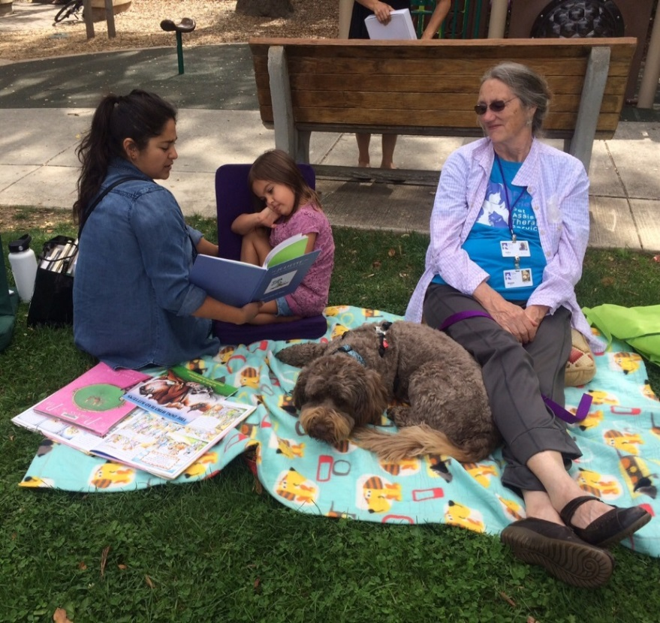

**Benchmarks**

**Increase In**: cardholders, circulation, visits, database use, computer use, and program attendance.

**Capacity Increase In**: number of public access computer, hours of computer and wireless use, type and number of technology programs.

**Measure Success**: Analyze findings and amend functions to improve patron satisfaction.

**Increase Partnerships**: Maintain current strategic partnerships and identify additional partners.

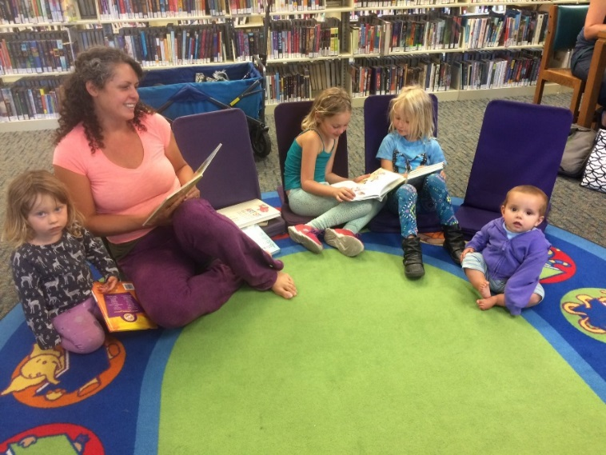

**Governance, Funding, and Budget Overview**

The Santa Cruz Public Libraries (SCPL) system is one of two library systems in Santa Cruz County. SCPL serves its region independently although it shares revenue sources with the Watsonville Public Library.

**Governance**

The Santa Cruz Public Libraries operate under a Joint Powers Agreement among the County of Santa Cruz and the Cities of Capitola, Santa Cruz, and Scotts Valley.

Members of the Joint Powers Board are the County Administrative Officer from the County of Santa Cruz, the City Manager from the City of Capitola, the City Manager from the City of Santa Cruz, and the City Manager from the City of Scotts Valley.

The original Joint Powers Agreement was forged in 1996. In December 2015, all four jurisdictions approved the Fourth Amendment to the Joint Powers Agreement and that is the current governing document for the Santa Cruz Public Libraries.

**Library Advisory Commission**

The Library Advisory Commission is intended to be a voice of the community to provide advice and feedback to the Governing Board and the Director of Libraries. The Commission will review programs and services and make necessary recommendations as they pertain to the provision of these programs and services.

The Commission consists of the following Commissioners who must be registered voters:

* Three (3) residents of unincorporated Santa Cruz County appointed by the serving at the pleasure of the County Board of Supervisors, with one each from Supervisorial Districts 1, 2 and 5.
* Two (2) Santa Cruz city residents appointed by and serving at the pleasure of the Santa Cruz City Council.
* One (1) Capitola resident appointed by and serving at the pleasure of the Capitola City Council.
* One (1) Scotts Valley resident appointed by and serving at the pleasure of the Scotts Valley City Council.

**Funding**

Both the Santa Cruz Public Libraries system and the Watsonville Public Library are supported by City and County property and sales taxes and private donations. There are three sources of local public revenues:

* The Cities of Santa Cruz and Watsonville contribute money from their general funds.
* Property taxes allocated for library services are collected by the County in the unincorporated areas and the Cities of Capitola and Scotts Valley
* A quarter cent sales tax designated for public library service is collected throughout the County

A Library Financing Authority divides these revenues between the City-County Library System and the Watsonville Public Library, based on a population formula which gives Watsonville credit for serving people who live in the unincorporated area close to that city.

SCPL library services are provided through the Fourth Amendment of the Library Joint Powers Agreement with the funds made available by the Santa Cruz County Library Financing Authority.

Santa Cruz Public Libraries has a modest income from bequests, fine revenue, donations from the public and the Friends of the Santa Cruz Public Libraries, Inc.

**Budget**

The Budget process begins no later than March 31st of each year with the Board providing service and budgetary priorities leading to the development of the Director of Libraries proposed operating and capital budget. A Public Hearing on the proposed budget shall be held no later than May 31st with copies of the budget made available 10 days prior to the public hearing. To adopt a budget, unanimous approval by the Board is required (Fourth Amendment to the JPA; Section 8).

**Budget Assumptions**

The Santa Cruz Public Libraries is not alone with facing an unstable financial future where the highest probable outcomes are: current cost increases outpacing revenue growth; revenue growth is threatened from a probable economic slowdown; and service expectation will increase as new and remodeled branches are brought online.

Provide below are the most recent, updated long-term financial forecast for the system that includes the proposed $14.4 million FY 2018-2019 Budget with a potential, projected surplus up to $600 K (assumes 94% of the budget is actually used). This forecast is influenced by the probability of a moderate economic slowdown, the continued shrinking of the sales tax base, the known and projected increases in State Pension fund payment to make up for the State’s investment shortfalls, moderate increases in health care, and minimal operating changes.

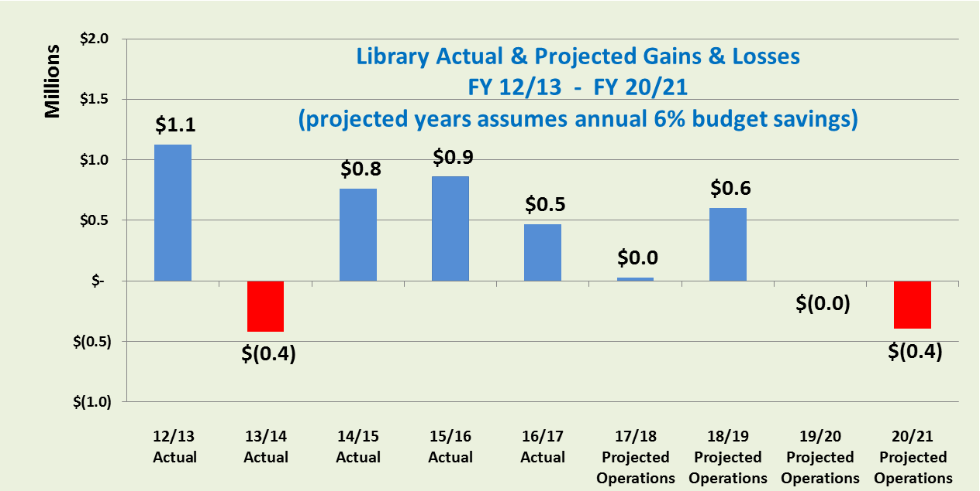

Significant components of the Santa Cruz Public Libraries FY 2018-2019 Budget were based on the following assumptions provided by the City of Santa Cruz’s Finance Department. The City is contracted by the system to provide administrative services, including financial services.

|  |  |  |  |  |  |
| --- | --- | --- | --- | --- | --- |
| Key Growth Assumptions | Prior Actual | Current  Projected | FY 2019 | FY 2020 | FY 2021 |
| Sales Tax | 3.1% | 4.0% | 2.75% | 2.5% | 2.0% |
|  |  | | | | |
| Budgetary Personnel Vacancy | 8.6% | 0% | 3.0% | 3.0% | 3.0% |
|  |  | | | | |
| Pension- normal & shortfall | 17.7% | 16.5% | 19.1% | 16.5% | 23.0% |
|  |  | | | | |
| Health Care | 5.3% | <2.7%> | 4.0% | 2.0% | 2.0% |
|  |  | | | | |
| Total Budget savings | 9.4% | 6.0% | 6.0% | 6.0% | 6.0% |

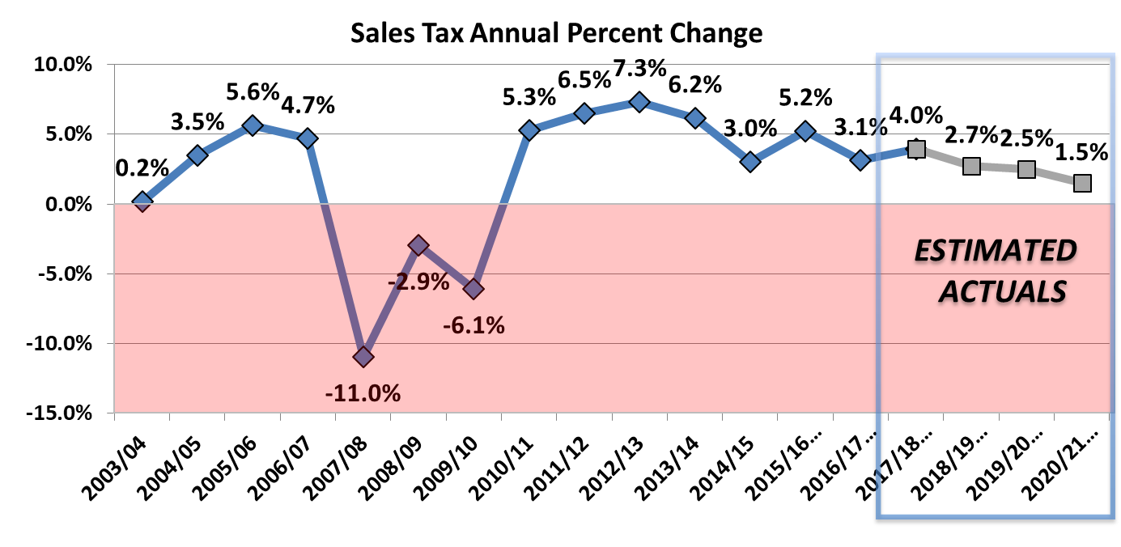***Sales tax.*** Prior sales tax projections were more pessimistic for FY 2019 and beyond, but were recently upgraded based on recent actual results. While we are still predicting a decline in the rate of growth, we continue to feel a little bullish for overall tax growth in the next few years. Our major concerns with sales tax are (1) the level in which it will be impacted by a looming, projected economic slowdown; and (2) the continued deterioration of the taxable sales base. Our models assumes a slowdown impacting sales tax towards the end of FY2019 and continues through FY2022; and the continued deterioration of the taxable sales base. The table below shows the annual change in sales tax revenue and is a reminder of fluid nature of sales tax and the speed it is impacted by a slowdown.

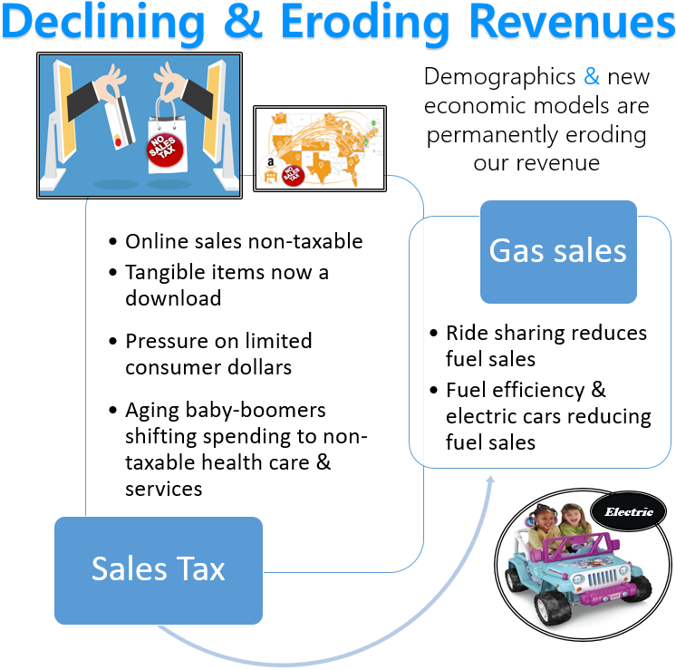

This illustration highlights the major actions that are shrinking the taxable sales base. With the threats from an economic slowdown and the declining sales tax base, it continues to be important to reiterate that the system is currently entirely reliant on sales tax growth to offset all cost increases. That is unless members agree to increase their own contributions.

***Staffing, Pension & Health costs***. Another critical element of the forecast is the growth in base compensation and benefit costs. In recent years, the Library has enjoyed budgetary savings for salary and benefits in the 3% range. However, in the current year, the Library is on a pace to consume their entire budget for salary driven by increases in temporary staffing. Nonetheless, our model includes an assumption that it will return to a 3% salary savings rate for next year and 6% overall for the entire budget. This assumption should be closely monitored by Library operations and may be adjusted downward with the uncertainty around staffing impacts from the various system construction projects.

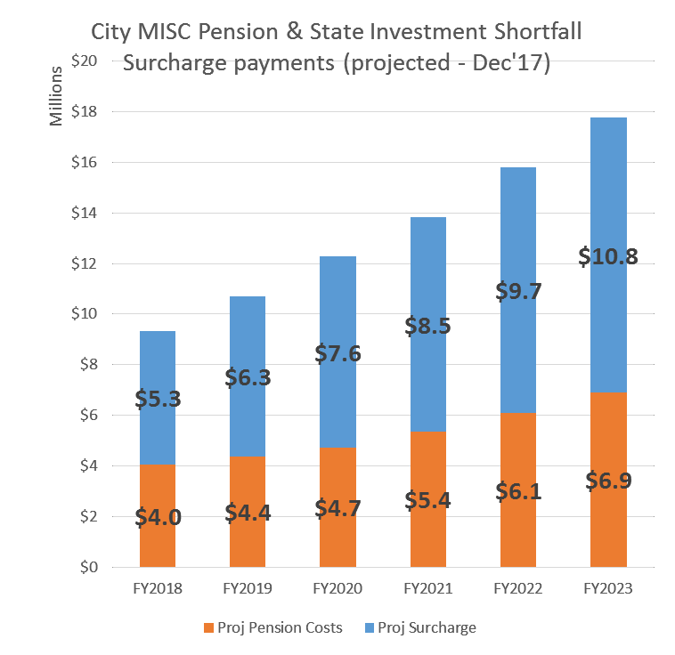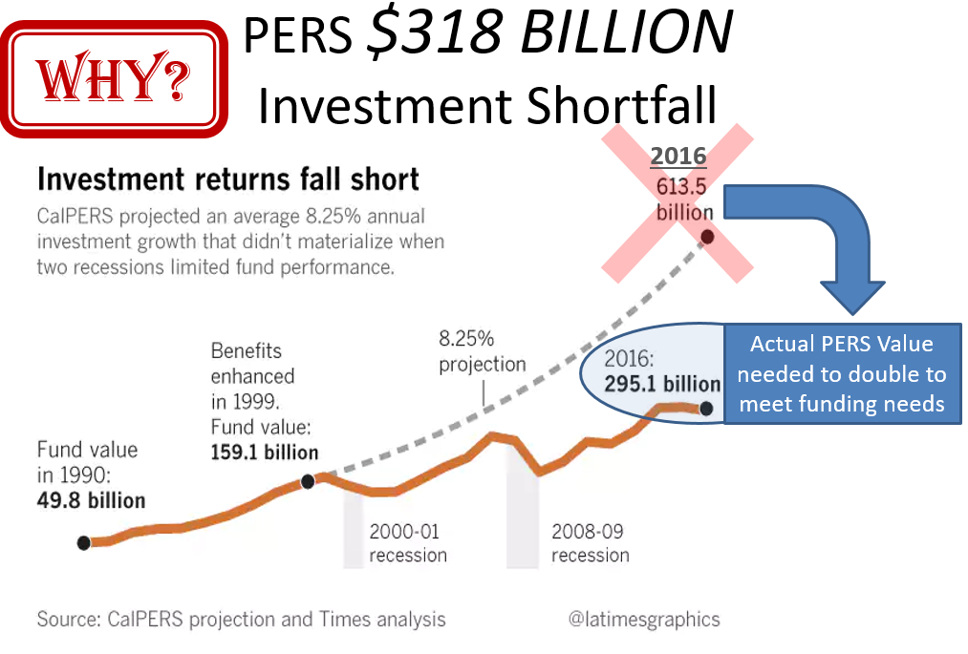Within total employee compensation, two benefit systems are having opposite trend patterns. Pension payments to the State are projected to be on a continued, steep increase through the mid-2020s, driven by the need to backfill the State pension fund for poor investment performance and prior year investment losses.

The Library JPA employees are all employed by the City of Santa Cruz and accordingly follow the “Miscellaneous” (general non-safety employees) group costs. As the table illustrates, the normal costs for all City and Library employees (bottom & orange) are growing at reasonable rates. However, the surcharge to backfill the State fund for investment losses and shortfalls (blue) is already double the normal benefit costs, and will double again in the next 5 years.

The increases in Library JPA employee health care premiums, on the other hand, have been lower than those of general City employees, due to the differences in demographics, and/or the plans that Library employees choose. Another factor in lower health care rates were the CalPERS health plan premium reductions for 2018.

But, despite the likely 2.7% reduction in the Library JPA’s current year health care costs, our projection includes an expected, annual increase between 2% to 4%. This is based on the expectation of health care costs following the longer term trends from CalPERS health and our own cost data. City staff will continue to monitor these rates. In addition, we expect to get soon from CalPERS next year’s projected health care premiums.

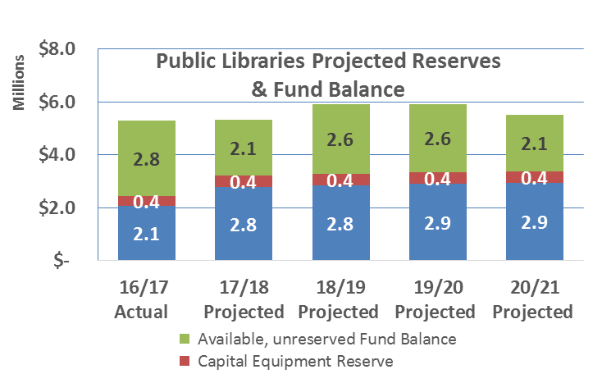

***Fund balance***. The Board has set two reserves, a 20% stabilization operating reserve and a reserve for capital equipment. Both reserves are funded at their current levels throughout the current forecast. Beyond reserves, the system’s available Fund Balance (green) is projected to peak at $2.6 million in 2018-2019.

|  |  |  |  |  |  |  |  |  |  |
| --- | --- | --- | --- | --- | --- | --- | --- | --- | --- |
|  | | | | | Fiscal Year 2019 |  | | | |
|  |  |  | 2018 Adopted Budget |  | 2018  Adjusted Budget |  | 2018  Estimated  Actual |  | 2019  Recommended  Budget |
| **Expenditures by Activity:** |  |  |  |  |  |  |  |  |  |
| Personnel Services |  |  | 10,058,899 |  | 10,058,899 |  | 10,058,899 |  | 10,133,492 |
| Services, Supplies & Other  Charges |  |  | 3,990,114 |  | 4,332,519 |  | 4,364,367 |  | 4,055,852 |
| Capital Outlay |  |  | 183,300 |  | 215,645 |  | 186,400 |  | 187,800 |
| Total Budget - Expenditures |  |  | 14,232,313 |  | 14,607,063 |  | 14,609,666 |  | 14,377,144 |
| Estimated Budgetary Savings  (Not Adopted) |  |  | (620,000) |  | (620,000) |  | (620,000) |  | (770,000) |
| Projected Actual Expenditures |  |  | $13,612,313 |  | $13,987,063 |  | $13,989,666 |  | $13,607,144 |

|  |  |  |  |  |  |  |  |  |  |
| --- | --- | --- | --- | --- | --- | --- | --- | --- | --- |
| **Activity Resources:** |  |  |  |  |  |  |  |  |  |
| Taxes |  |  | 7,994,000 |  | 7,994,000 |  | 7,994,000 |  | 8,113,910 |
| Member Contributions |  |  | 5,585,273 |  | 5,585,273 |  | 5,585,273 |  | 5,655,273 |
| Charges for Services |  |  | 0 |  | 0 |  | 2,320 |  | 4,640 |
| Fines and Forfeits |  |  | 140,500 |  | 140,500 |  | 140,500 |  | 140,500 |
| Rents & Misc Revenues |  |  | 91,948 |  | 96,673 |  | 110,895 |  | 85,543 |
| Other Financing Sources |  |  | 39,190 |  | 0 |  | 53,644 |  | 84,190 |
|  | Total Resources |  | $13,850,911 |  | $13,816,446 |  | $13,886,632 |  | $14,084,056 |
| **Total Operational Surplus or (Deficit)** |  |  | **$238,598** |  | **$(170,617)** |  | **$(103,034)** |  | **$476,912** |

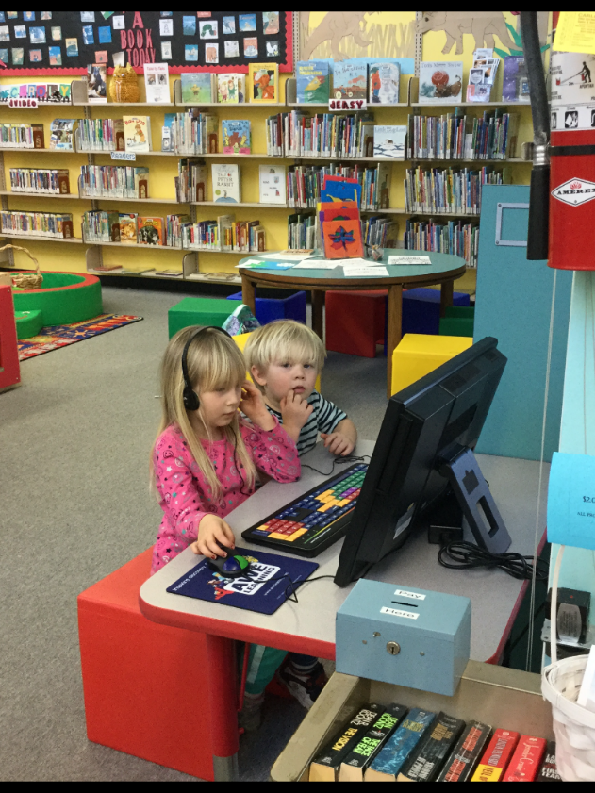

**Library FAQs**

Facilities: 10

Registered Users: 141,916

Items Checked Out: 1.7 M

Electronic Material Check Out: 136K

Programs: 1,935

Programs Attendance: 50,745

Library Visits: 1.1M

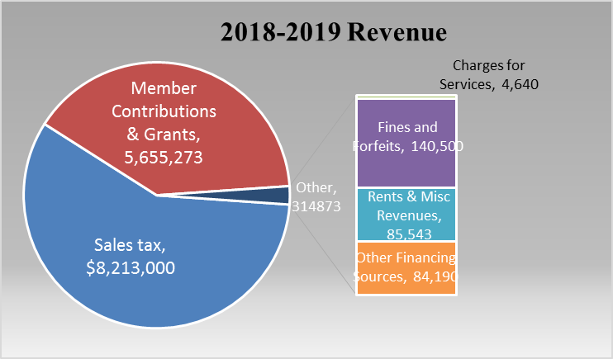

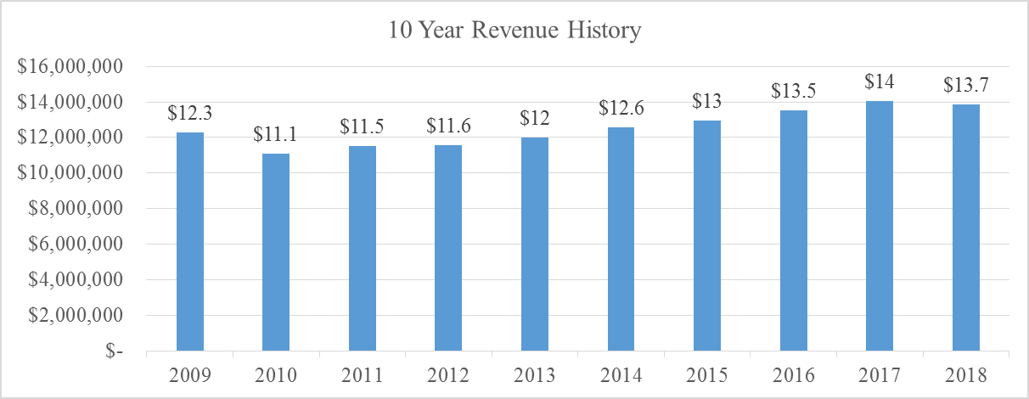

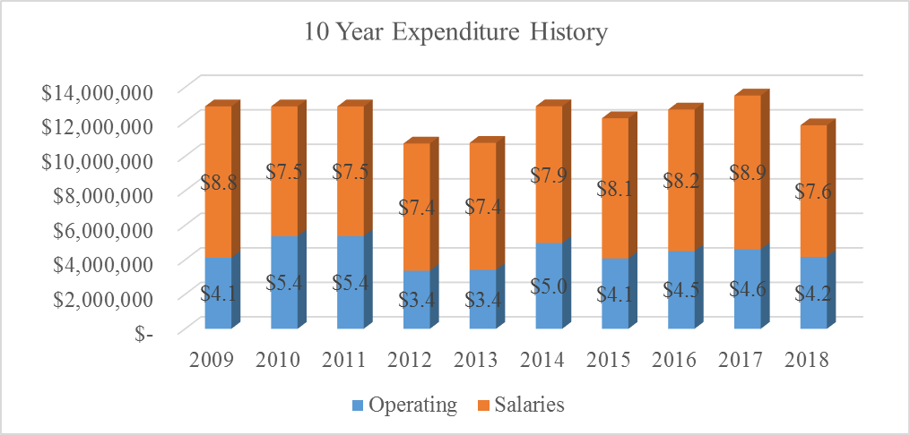

**Projected Library Revenues**

Santa Cruz Public Libraries system is supported by City and County property and sales taxes and private donations. There are three sources of local public revenues:

* The Cities of Santa Cruz and Watsonville contribute money from their general funds.
* Property taxes allocated for library services are collected by the County in the unincorporated areas and the Cities of Capitola and Scotts Valley. The MOE is projected to grow 1.3%.
* A quarter cent sales tax designated for public library service is collected throughout the County. Sales tax is projected to grow 2.7%.

Santa Cruz Public Libraries has a modest income from bequests, fine revenue, donations from the public and the Friends of the Santa Cruz Public Libraries, Inc.



**Projected Library Expenditures: Major Changes**

The Santa Cruz Public Libraries (SCPL) system delivers information, education, enrichment and inspiration through a network of 10 neighborhood library branches, a web-based digital library, a Bookmobile and community-based programs. SCPL serves children, teens and adults with innovative programming, professional services and community facilities that spark imagination and support discovery. Residents can explore a wide range of interests from academic research, book clubs and literacy programs to digital photography, locally-produced music and local history. Branch locations include Aptos, Boulder Creek, Branciforte, Capitola, Downtown Santa Cruz, Felton, Garfield Park, La Selva Beach, Live Oak and Scotts Valley.

The following lines have seen increases above/below 10%:

|  |  |  |  |
| --- | --- | --- | --- |
|  | % Change | $ Change | Description for Change |
| Downtown Library Security Patrols | -12.2% | -$1,101 | Changes in city-wide contract |
| Merchant Bank Fees | 20.1% | $419 | Increase in Contract Pricing |
| Office Equipment O & M | -23.4% | -$1,100 | Reduction in Contract with the Closure of Capitola |
| Vehicle Maintenance | 160% | $4,500 | Increase in City fleet maintenance |
| Landscape Maintenance | 25.6% | $9,303 | Increase in contract pricing |
| Hardware | 30.6% | $11,000 | Dell maintenance and SV media wall contract increases |
| Building Rental | -22.1% | -$69,164 | Reduction in square footage of Administrative offices |
| Telecommunications | 49.9% | $56,478 | CENIC at all Braches |
| Printing | 25.5% | $5,000 | Increase in summer reading costs |
| Books and Periodicals | -20.1% | -$290,740 | Roll over appropriations have not been made for FY19 |
| Grants & Donations | -83.0% | -$12,900 | Fleming Trust has been exhausted |
| Safety Clothing/Equipment | 101.4% | $6,450 | Additional ergonomic assessments scheduled |
|  | % Change | $ Change | Description for Change |
| Library Functional Supplies | -20.1% | $35,700 | No need to re-order library cards this year |
| Janitorial Supplies | -32.3% | -$10,000 | Not including additional supplies needed for increase in mid-day cleaning services |
| Misc. Supplies | -30.5% | -$47,240 | Innovation Grant was approved for FY18 and is pending for FY19 |
| Office Furniture/Equip | 178.1% | $11,400 | Office chairs needed to be ordered |





**Projected Library Fund Balance**

The Santa Cruz Public Libraries (SCPL) Board has designated two reserves, a 20% stabilization operating reserve and a reserve for capital equipment. Both reserves are fully funded at their current, required levels and are forecasted to remain fully funded through the current forecast period. As demonstrated in the table below, the operating and equipment reserves are projected to peak at $3.4 million in 2020-2021. Beyond reserves, the system’s available Fund Balance (green) is projected to peak at $2.6 million in 2018-2019. This later projection is dependent upon the SCPL spending at or below just 94% of their total, appropriated budget levels (based on historical patterns of annual budget savings).



**Proposed Changes**

|  |  |  |
| --- | --- | --- |
|  | 2017-2018  Adopted | 2018-2019  Proposed Budget |
| Revenues | $13,850,911 | $14,084,056 |
| Personnel | $10,058,899 | $10,133,492 |
| Expenditures | $4,173,414 | $4,243,652 |
| Total Operational Surplus or <Deficit> | <$381,402> | <$293,088> |
| Reserve Applied to Personnel | $381,402 |  |
| Budgetary Savings | $620,000 | $770,000 |
|  |  |  |
| Proposal #1  Elimination of Children’s Fines** |  | $25,300 |
| Proposal #2  Innovation Grant Funding |  | $50,000 |
| Proposal #3  DTN & B40 Restroom Cleaning |  | $45,000 |
| Proposal #4  Building Maintenance |  | $100,000 |
| Proposal #5  Temporary Budget |  | $100,000 |
| Proposal #6  Books & Materials |  | $150,000 |
| **Total Operational Surplus or <Deficit> with Proposed Changes** |  | **$6,612** |

**Adopting this proposal would also allow the library to write off accounts receivable for children’s late fees.

***Proposal #1***

Revenue Change: Eliminate Overdue Fines on Materials for Kids 0-18 year old

*Cost:* <$25,300> annually

*Discussion:*

For decades, SCPL had no overdue fines on juvenile cards. Fines were imposed during a budget crisis, and have resulted in 17% blocked juvenile accounts.

It is a foundation of our Strategic Plan to nurture the learning goals of children and adults. To enable this, we propose that fines be eliminated on materials from the Juvenile and Young Adult collections. We also propose an amnesty period to enable our young patrons to get a fresh start with clean cards.

The American Library Association promotes equal access to information for all persons, and recognizes the urgent need to respond to the increasing number of poor children, adults, and families in America. The first recommended action to implement this objective is promoting the removal of all barriers to library and information services, particularly fees and overdue charges. 1

We currently have 21,415 library card-holders between 0-18 years of age.  Unfortunately, outstanding fines block 3,689 young people (or 17%) from borrowing any more materials. Accounts are blocked when they reach $10 in fines. Over 80% of these blocked patrons owe overdue fees, and less than 20% have lost any items. The revenue from juvenile fines in 2017 was $25,300, which is only 0.19% of our budget.

Our experience is that many fines will never be paid because those children don't come back to the library any more. In Santa Cruz County, 43% of students come from low-income families. 2 The only effect these fines have is to make a barrier that stops them from using the library.

There are many compelling reasons to eliminate fines on materials predominately used by children and teens.  As stated earlier, the fines collected represent only a tiny portion of the budget. Additionally, one of the reasons children accrue fines is lack of access to the library as they seldom have their own transportation or control over their schedule. Anyone, including children, who checks out materials intends to return them on time.

The major argument against fines is that they impose a barrier to borrowing, or even to consider joining the library, for those who cannot afford to pay them. Fines disproportionately affect those that have most need of our materials.

The income generated is a very small percentage of the overall budget. The cost of collecting the fines can be high in terms of staff time and stressful patron interactions.

Patrons with $10 or more in fines are blocked from borrowing any more items, even if they have returned everything. Only 3% of juvenile cards are blocked for lost items, but 14% are blocked due to late fees.

A study by The New York Public Library 3 examined the true cost of fines (2017). "For those who can afford the fines, paying a small late fee is no problem, so the fines are not a particularly strong incentive. On the other hand, for those who cannot afford the fines they have a disproportionately negative impact." They offered an amnesty period first, and found that this helped to recoup many "Lost" items. Students could get a fresh start and they saw a 10% increase in use within the first month. Their fine-free program for NYC public school students encouraged 37% more borrowing than for students not in the program. Students have to return their items before checking out new ones, and still pay for lost items.

The fine-free movement is growing. When Stark County District Library in Ohio waived fines in 2014 they saw over 10% increase in circulation and no significant increase in lost items during the first year.

In Los Angeles, district students have automatically received city library cards that accrue no overdue fees beginning in 2016. Students can check out three books at a time. About 15,000 have used the new cards. 4

San Rafael Library removed fines from Youth materials in 2015, and have seen an increase of almost 40% in youth card registrations. They found no change in the number of 21 day overdue notices, so the lack of fines did not result in patrons keeping the books longer. 5

The Peninsula Library System eliminated fines for juvenile cards last year (2017). They had an increase in student card registrations of 61% and a 33% increase in youth circulation. "Loss of revenue was minimal given the positive impacts." 6

For decades, SCPL had no overdue fines on juvenile cards. Fines were imposed during a budget crisis, and have resulted in 17% blocked juvenile accounts.

It is a foundation of our Strategic Plan to nurture the learning goals of children and adults. To enable this, we propose that fines be eliminated on the Juvenile and Young Adult collections. We also propose an amnesty period to enable our young patrons to get a fresh start with clean cards.

Sources:

1. ALA Policy Statement: Library Services to the Poor. <http://www.ala.org/aboutala/offices/extending-our-reach-reducing-homelessness-through-library-engagement-7>
2. “Percentage of Students Receiving Free or Reduced-Cost Meals.” Santa Cruz County Community Assessment Project, Year 23, 2017.
3. The case against library fines - according to the head of The New York Public Library, by A.W. Marx, Dec 18, 2017, <https://qz.com/1158839>
4. No more library fines for most young readers in L.A. County, by Howard Blume, Dec 25, 2017, L.A. Times.
5. Personal communication, Sarah Houghton, Director San Rafael Public Library, Aug 22, 2017.
6. Impacts of eliminating youth overdue fines, by Derek Wolfgram, Peninsula Library System Administrative Council, Oct 12, 2017.

Please see Appendix D: School Superintendents letter of support.

***Proposal #2***

Innovation Grant Funding

*Cost:* $50,000

*Discussion:*

The Library would like to continue to fund the Innovation Grant project that the library launched in FY18. These grant funds are offered to staff in an effort to try out ideas to improve or introduce programs and services offered by the Santa Cruz Public Libraries. They might also be ideas that improve efficiency in our system.

***Proposal #3***

Additional Restroom Cleaning for Downtown and Branciforte

*Cost:* $45,000

*Discussion:*

Additional restroom cleanings for Downtown and Branciforte were ordered in FY 18 in response to the Hep A outbreak. The library would like to continue these efforts in order to keep these restrooms clean and in good working order during the day.

***Proposal #4***

Building Maintenance

*Cost:* $100,000

*Discussion:*

The Library is in need of addressing a few high priority building repairs at some of our facilities. These projects are outside the Measure S project timelines and their need is immediate. For example, the skylights at Boulder Creek are failing and are in need of replacement. When that branch experiences rain the skylights leak and create damage not only to the facility but also to the materials inside.

***Proposal #5***

Temporary Budget

*Cost:* $100,000

*Discussion:*

The Library is experiencing higher than expected rates of unfilled shifts. This means that an absence has been entered by a regularly scheduled staff member at a branch and the shift is unable to be filled. Our temporary pool of employees has a high turnover rate which has led to the shortage. A recent report was run for the month of April and the number of unfilled Library Aide shifts ran at an average of 54% each week. An increase in this budget line would allow the library to hire more temporary workers in order to help fill these shifts.

***Proposal #6***

Books & Materials

*Cost:* $150,000

*Discussion:*

The Board has agreed that our library system should be spending 11% of our budget on materials which is the national average. Currently we are spending 8% of our budget on materials for the system.

**Position Listing by Classification**



Note: In 2008 the FTE for the library system was 120.63.

**Appendix A:**

**Expenditures by Administration & Branch**

The following reports are expenditures broken down by administration and branch.

























**Appendix B:**

**Trust Fund Narratives**

ANNA GRUBER BEQUEST

Donor: Anna Gruber died in 2012 leaving the Library a bequest

Terms: The Anna Gruber Trust gave the bequest to the Library for library materials for Branciforte with the understanding items do not stay in any one branch.

Balance of

Trust as of

3/31/17: $17,159

Income: Interest earned is added to principal

Management: Held by the City Finance Department. CMS Manager manages the funds.

Plans: Spend out trust.

FINKELDEY TRUST

Donor: Stella A. H. Finkeldey, a teacher and principal in the Santa Cruz City School System, left her estate to the Santa Cruz Public Library in 1949.

Terms: “….the net income there from, plus the annual sum of $100.00 from the principal, [shall] be used and expended solely for the purchase of musical literature for and to be kept in the music department of the Santa Cruz Public Library.”

Balance of

Trust as of

3/31/17: $9,002

Income: Interest earned is added to principal

Management: Held by the City Finance Department. Complete record is reflected in Library budget. CMS Manager manages the funds.

DOROTHY A. HALE TRUST

Donor: Dorothy A. Hale died in 2011 leaving the Library a bequest.

Terms: The Dorothy A. Hale Trust specifies that the Library use the funds for “the Scotts Valley Branch of the Santa Cruz Public Library System.

Balance of

Trust as of

3/31/17: $45,977

Income: Interest earned is added to principal

Management: Held by the City Finance Department. Regional Manager, Laura Whaley, manages funds.

LEET-CORDAY TRUST

Donor: Robert Leet-Corday

Terms: The Leet-Corday Trust specifies that the Library use the funds for the Downtown (Central) Branch of the Santa Cruz Public Library System for “providing vibrant physical and virtual public spaces”.

Balance of

Trust as of

3/31/17: $95,838

Income: Interest earned is added to principal

Management: Held by the City Finance Department. DTN Regional Manager manages funds.

MCCASKILL TRUST – LOCAL HISTORY

Donor: Annie McCaskill, who died in 1981, named the City of Santa Cruz as one of the two residual legatees for her estate. The other was the First Presbyterian Church. Upon the death of her sister, Francis McCaskill, the City’s share of the estate was to be divided into two equal parts: one for local history and the other for providing materials and services to people who are visually impaired. Francis McCaskill died in 1986, and the Library received its distribution during the summer.

Terms: Half the City’s share is to be used “in establishing and maintaining a department in the City of Santa Cruz Public Library System devoted to the preservation of historical documents and objects and promulgation of the local history of the City of Santa Cruz and of the State of California.” No limitations on only spending income.

Balance of

Trust as of

3/31/17: $215,257

Income: Interest earned is added to principal

Management: Held by the City Finance Department. Asst. Director manages funds.

MCCASKILL TRUST – VISUALLY IMPAIRED

Donor: See above

Terms: Half the City’s share of the McCaskill Trust is to be used “in establishing and maintaining a Braille department in the City of Santa Cruz Public Library System and for the purpose of providing Braille books, materials, records, and tapes for use of persons with defective sight.”

Anticipating major cuts in the Library’s 1986-87 materials budget, the Library Board agreed in July that $15,000 in income from this Trust should be used to support the purchase of large print and talking book tapes for adults and children during the current fiscal year. It has been approved that continuing after this, the money could be spent in any way that benefitted the visually impaired and was not limited to the purchase of Braille materials.

Balance of

Trust as of

3/31/17: $204,381

Income: Interest earned is added to principal

Management: Held by the City Finance Department. CMS Manager manages funds.

JAMES MORLEY TRUST

Donor: James Morton Morley died on February 1, 2011, leaving the Library a bequest.

Terms: The James Morton Morley Trust specifies that the Library use the funds for “improvements or enhancements to the La Selva Beach Library Branch or the Aptos Branch if the La Selva Beach Branch has been or is scheduled to close”.

Balance of

Trust as of

3/31/17: $13,260

Income: Interest earned is added to principal

Management: Held by the City Finance Department. Regional Manger manages funds.

RICHARDSON TRUST

Donor: Dr. James B. Richardson died in 1979, leaving the Library a Testamentary Trust for book purchases. His other legatees were the Cornell University Veterinary School and a personal friend.

Terms: The Richardson Will specifies that the Library use the funds “for the purchase of nonfiction books written for the general public, and not to include textbooks, technical or statistical books, or religious or sociological studies.”

Balance of

Trust as of

3/31/17: $325,000

Income: In 1981 the Superior Court ruled that all net income be distributed annually, one-fifth to Cornell (for research on dogs) and four-fifths to the Library.

Management: Held by Comerica Bank. Check is received annually in May and that is appropriated into the Library’s annual budget. CMS Manager manages this trust.

WILLIAM COX SULZNER TRUST

Donor: William Cox Sulzner, also known as Lee Cox Sulzner, gave his estate to FSCPL to establish an endowment in his name.

Terms: “The net income of this fund shall be used to purchase mystery books, mystery tapes or other media, all of which shall bear my name as the donor.”

Balance of

Trust as of

3/31/17: $141,579

Income: Interest only.

Management: FSCPL holds this trust. CMS Manager manages this trust.

UTTER TRUST

Donor: Herman A. Utter and Ruth H. Utter Fourth Restatement of Trust Agreement dated May 7, 1992 restatement dated August 6, 2004

Terms: “To support the purchase of library materials and special library programs.” (March 2017)

Balance of

Trust as of

3/31/17: $293,783

Income: Interest Only

Management: FSCPL holds this trust. Held at Community Foundation of Santa Cruz County. Asst. Director manages these funds.

WHALEN TRUST

Donor: Family Trust of Kenneth H. Whalen and Shirley M. Whalen. Kenneth Whalen died on December 1, 2008, leaving the Felton Branch of the Library a Trust for capital improvements and book purchases.

Terms: The Whalen Trust specifies that the Library use the funds for the Felton Branch “for capital improvements and/or new books”.

Balance of

Trust as of

3/31/17: $95,332

Income: Interest earned is added to principal

Management: Held by the City Finance Department. CMS Manager manages funds.

Plans: Felton opening day collection TBD.

**Appendix C:**

**Vehicle Replacement Schedule**



**Appendix D: School Superintendents Letter of Support for the Removal of Children’s Late Fees**

To the Santa Cruz Public Library Board:

We are writing as public school librarians in support of Santa Cruz Public Library’s proposal that children and young adult materials incur no fines.

As librarians, we encourage children to use public libraries in addition to school libraries by getting library cards.  And, every year, a small chorus of children tells us that they are not able to use the public library due to fines. These voices belong to our least able to pay, often from families unable to advocate for themselves and from families needing literacy support.  Removing fines for children and young adults would create more equitable access to library resources.

Thank you for considering a change in this policy so our children may continue to use and enjoy the public library and its resources.

In support,

Santa Cruz City School Librarians

Madeline Britton

Jessica Brooks

Martha Dyer

Shannon Greene

Kathy Griffith

Jolene Kemos

Barbara Lawrence

Adriana Lugo

April Porterfield

Veronica Zaleha